**LEBANESE AMERICAN UNIVERSITY**

**USAID – HIGHER EDUCATION SCHOLARSHIP PROGRAM**

**HES - Volunteering Program Verification Form**

This form is to be used to document volunteering hours. If a student volunteers for multiple organizations, a separate form must be used for each organization. **This form must be turned in by the 28th of each month, the latest.**

I certify that the scholar Malak Ziad Mershad completed a total of 5 hours of service at InnovaThrive.

The hours were completed hours as per the below:

Hours # 5 (date) _2/12 – 6/12_ (initials of supervisor) __A.K.___

Hours # 0 (date) _9/12 – 13/12_ (initials of supervisor) __A.K.___

Hours # 0 date) _16/12 – 20/12 (initials of supervisor) __A.K.___

Hours # 0 date) _23/12 - 27/12 (initials of supervisor) __A.K.___

Brief description of the activities the scholar performed or participated in:

I was tasked with examining the role of gratitude in the prosperity and continuity of relationships within the field of psychology. I was surprised by how a simple act of gratitude—whether it's thanking your partner or a friend, expressing love through words, or giving a thoughtful gift—can have such a profound impact on a relationship. I learned that these small acts can help resolve conflicts and promote long-term relationship health.  
  
Additionally, I discovered that people express gratitude in different ways, which can sometimes lead to misunderstandings. A gesture of gratitude from one person may be interpreted differently by the other, causing confusion or conflict. This highlighted the importance of understanding the cultural and personal backgrounds of the people you're interacting with, so you can choose your actions more thoughtfully. Overall, this topic was fascinating, demonstrating that even small gestures can make a significant difference in maintaining strong, healthy relationships.

Written feedback about the scholar’s performance:

Malak’s research on the role of gratitude in relationships highlighted how small acts of gratitude can strengthen bonds and resolve conflicts. The insight into cultural and personal differences in expressing gratitude adds depth to understanding relationship dynamics and how these gestures promote long-term relationship health.

Please rate the overall performance of the scholar at your organization:

|  |  |  |  |
| --- | --- | --- | --- |
|  | Mastery (5) | Proficient (3) | Emerging (1) |
| **Problem solver** | X |  |  |
| **Engaged & Committed** | X |  |  |
| **Open-minded & multicultural** | X |  |  |

Signature

& stamp

__________________________

_

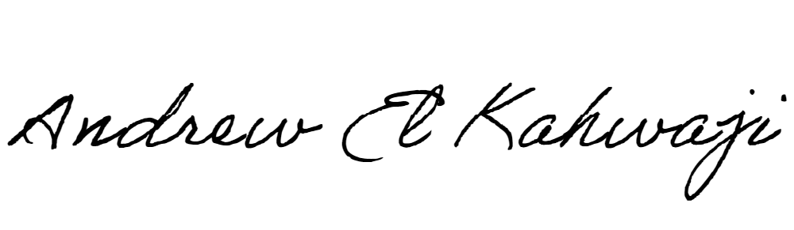

Printed Name _Andrew El Kahwaji_

Date __26/12/2024___

Email __andrew.lifesculptor.coo@gmail.com __

Phone __+961 71 914 378__